Effect of Trade Network Relations of Natural Resources Sectors on Political Stability

Group Members: Wanran Zhao, Richard Ye, Haotian Zong

# Research Question

What’s the effect of involvement in Global Value Chain (GVC) in natural resources sectors of countries on their political stability?

# Background

Global value chain (GVC) depicts how countries are involved in different stages of production and trade across sectors and countries, including the production of intermediate goods and services that are used in the production process of final goods and services in other sectors or countries. GVC can often be represented by a (Input-)Output Table that contains the global flows of goods and services between sectors and countries. In this paper, we will focus on the country-level involvement in four single-sector trade networks: 1. agriculture, hunting, forestry, and fishing; 2. mining and quarrying; 3. coke, refined petroleum, and nuclear fuel; 4. basic metals and fabricated metal.

There are multiple established measures to measure country-level of involvement in the trade network. We plan to focus on two types of measures: network theory characteristics and GVC theory indicators.

Network theory characteristics stem from (social) network analysis theory that has gained importance in the field of international trade. Among various characteristics, we will focus on connectedness and centrality, following the methodology of [(Cappelli et al., 2023)](https://www.zotero.org/google-docs/?Y8tw6P). Connectedness evaluate which countries are most connected in the global trade, and centrality measures which are most central in the intermediation of trade flows. The formal definitions and formulae of these characteristics are given in [(Cappelli et al., 2023)](https://www.zotero.org/google-docs/?yxWNn1). We will present the technical detail in the final paper.

GVC theory indicators are developed within the theoretical GVC framework without resorting to network analysis theory. One of the most straightforward indicators is a country’s GVC-related output as percent of output. Some more computationally complex indicators include, for example, *backward GVC participation rate* refers to the ratio of foreign value-added content used to produce a country’s exports (in a certain sector), while *forward GVC participation rate* captures the domestic value added that is used in a bilateral partner’s export production [(Borin & Mancini, 2019)](https://www.zotero.org/google-docs/?2QwgBv).

Generally, network theory characteristics measure how important a country is in the global trade network, and GVC theory indicators measure how reliant a country is on the global trade network. We plan to explore the impact of both types of measures on a country’s political stability in our analysis. We will elaborate on the exact measures that we select in the paper.

# Literature Review

The theoretical basis of our proposal comes from [(Sachs & Warner, 2001)](https://www.zotero.org/google-docs/?bzk1gM) and [(Karl, 1997)](https://www.zotero.org/google-docs/?MxUCaI). Both works found that countries that were abundant in and relied heavily on natural resources tended to be cursed with lower economic growth, due to economic dependence (vulnerability to price shocks & market volatility), worse developmental outcomes, and more political instability, due to concentration of wealth and power in the hands of the elites. Building upon these findings, we will examine how network relations of industry sectors, specifically ones regarding natural resources such as agriculture, mining, oil, etc., which we will measure using GVC, can affect political stability of countries.

Our methodology follows [(Cappelli et al., 2023)](https://www.zotero.org/google-docs/?EYwtNL) that examine the role of network relations in the relationship between crude oil exports, international trade, and political stability. On the one hand, crude oil exports can provide a source of revenue for governments, leading to greater economic stability and improved social welfare. On the other hand, crude oil exports can also lead to greater political instability, as countries become more vulnerable to external shocks and suffer from the "resource curse" and "paradox of plenty" effects mentioned above. The network relations of the oil sector is one of the sectors that we will examine in our paper.

Additionally, [(Banerjee & Zeman, 2022)](https://www.zotero.org/google-docs/?mm0rTG) explore the determinants of GVC participation, including political instability. In comparison to their work, our research exploits GVC information using network analysis theory and contributes to the reverse causation and adds novelty to the established literature.

# Data and Key Variables

There are two major datasets that we will primarily use. The first one is World Integrated Trade Solution (WITS) GVC Output Tables database [(Manole, 2005)](https://www.zotero.org/google-docs/?I0IQvw). WITS integrates GVC Output Table from six different sources, including Asian Development Bank (ADB), Eora26, World Input-Output Database (WIOD) etc., allowing us to compute network theory characteristics and extract GVC theory indicators. These measures are our independent variables. The second dataset comes from [(Cotet & Tsui, 2013)](https://www.zotero.org/google-docs/?4xEZSv) who provide data from multiple political instability measures, like intense war onset, coup attempts, irregular leadership transitions, etc. These measures consist of our dependent variables. In addition, [(Cotet & Tsui, 2013)](https://www.zotero.org/google-docs/?YI5ML5) provision common control variables, like economic growth, inflation, democracy index, language and ethical fractionalization, for political stability.

Merged together, these datasets produce an unbalanced historical panel[1] that comprises 24 countries from 1965 to 2003 as our baseline sample if we use the WOID Long Run source from WITS. By switching to different data sources like ADB integrated by WITS, we may acquire a wider panel: with more countries that span fewer years.

Finally, we complement our database with the instrument variable, Logistics Performance Index (LPI), from World Bank [(Çetinkaya & Özceylan, 2021)](https://www.zotero.org/google-docs/?CTQHaL). LPI scores how efficiently countries move goods across and within borders by examining multiple facets, like customs performance and infrastructure quality. We believe LPI is a strong instrument, as [(Banerjee & Zeman, 2022)](https://www.zotero.org/google-docs/?KG6Eer) noted that LPI is one of the direct determinants of GVC involvement. Also, LPI satisfies exclusion restriction because it is (mostly) unrelated to a country’s political instability. Therefore, we can attempt to isolate the causal effect of the trade network involvement on political stability while controlling for other factors that might simultaneously affect both variables.

# Methodology and Analysis

## PART I: Classic Econometrics Method with IV and Fixed Effects

Our baseline model is a pooled regression of political instability measures on trade involvement, aforementioned controls, and instrument variable LPI. For example, we first investigate the trade involvement effect in the oil trade network, using a network theory measure (e.g. centrality) as our treatment and intense war onset as our consequent variable. In the TSLS manner, our first stage regression to is to fit for centrality $A^{*}$ with the instrument $Z$:

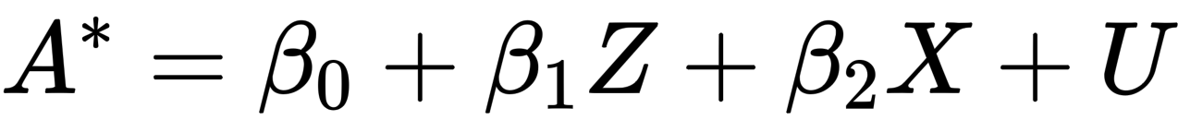

Then we will run second stage,

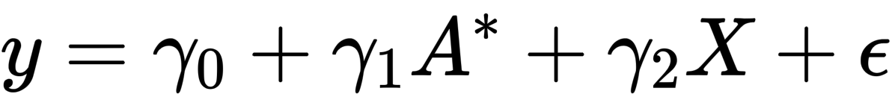

where $y$ is the outcome (political stability measured by intense war onset), $A^{*}$ is the fitted treatment (network centrality), $Z$ is the instrument (LPI), and $X$ is the controls such as economic growth and democracy level. Note, we include controls in the first stage regression because we believe the control variables like economic growth and democracy level can influence how our instrument Z affects our treatment, A.

Secondly, we will improve our baseline model by adding country fixed effect. The first stage is the same except we will add the country fixed effect:



And for the second stage, our model for country $i$ in year $t$ becomes:



where we just replace the invariant constant by the country-variant $α_{i}$ as the fixed effect for country.

Next, we will regress with just the time fixed affect. The first stage is the same except we will add the time fixed effect:



And for the second stage:



where we just add $δ_{t}$ as the fixed effect for time.

Finally, we would regress with two-way fixed effects, adding both the country( $α_{i}$) and time( $δ_{t}$) fixed effects, so the first and second stages are:

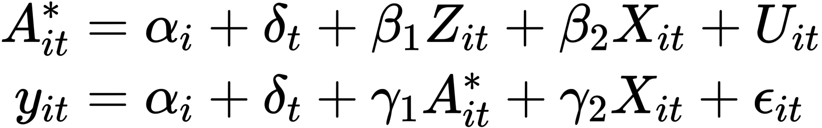

By using this two-way fixed effect, we should be able to control for unobserved heterogeneity at the individual country and time levels.

We then repeat the procedures above for various treatments (different network theory measures or GVC theory indicators) and different sectors. We expect nuanced variation in our results. For example, in line with the conclusion of [(Cappelli et al., 2023)](https://www.zotero.org/google-docs/?woxYgn), we hypothesize that countries heavily dependent on oil are largely exposed to political turmoil. This effect should be weaker in agricultural and other primary industries. Also, [(Cappelli et al., 2023)](https://www.zotero.org/google-docs/?YySnM1) suggested that oil-exporting and oil-importing countries are differently influenced in political outcome. Hence, we expect backwards and forwards GVC participation rates should produce different effects, because these indicators are opposite in the export-import dimension as explained in the Background section.

## PART II: Double Machine Learning Method

If time permits, we also plan to apply double machine learning techniques to further corroborate our findings from using two-stage least squares. Specifically, we will use the Local Average Treatment Effect (LATE) identification to estimate the average treatment effect on the treated (ATT). If the overlap condition is satisfied, the LATE can be identified as

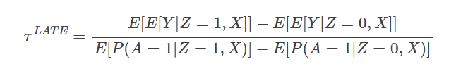,

where $Y$ is the outcome, $A$ is the treatment, $Z$ is the instrument, and $X$ is the control. ATT is can be better than ATE for us because we are only interested in the subgroup of countries that have the treatment, and ATE could dilute the treatment effect by including untreated countries. We will experiment with different outcomes and treatments, as well as working on different sectors, as described in PART I.

Since LATE identification requires the treatment and the instrument to be binary, we will convert the treatment variables (e.g. GVC participation rates) and the instrument (i.e. LPI) into categorical variables with 3 bins with equal frequencies. For example, GVC participation rates will be split into 3 bins with value 0, 1, and 2, each bin has $n/3$ samples in it, where $n$ is the total number of samples. Then, the data that fall into the second bin will be temporarily dropped when we estimate the ATT of each sector’s trade network relations on political stability. The data that fall into the highest bin will be regarded as taken the value $A=1$, and those that fall into the lowest bin as taken the value $A=0$. We will binarize the instrument $Z$ in the same way.

Admittedly, such binarization will reduce our sample size. If our sample size turns out to be so severely reduced that our analysis loses much of its statistical significance, we may divide the concerned continuous variables into quintiles and throw away only the middle quintile instead.

According to [(Rotnitzky et al., 1998)](https://www.zotero.org/google-docs/?0V3oRP), the double machine learning estimation procedure for casual inference can be briefly illustrated as below:

1. First, we define the following nuisance functions:

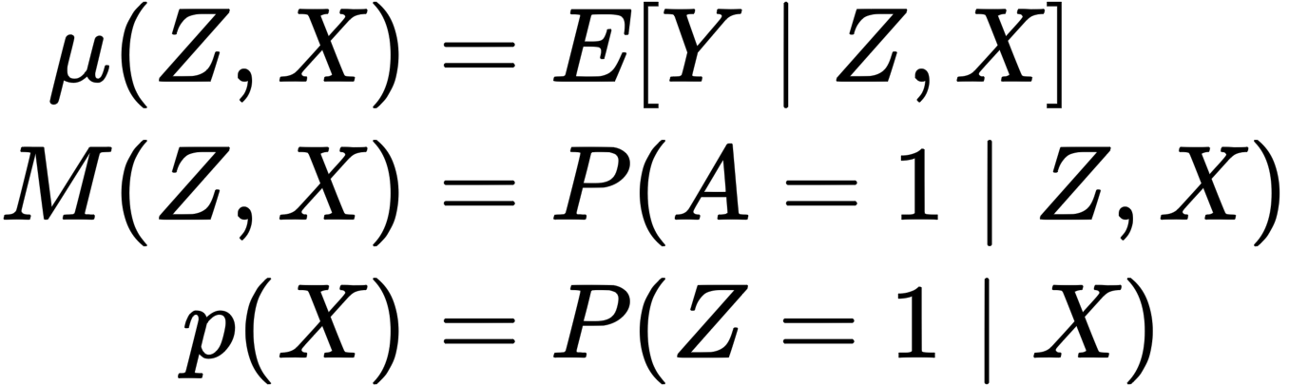

1. Next, we define the score function components using the nuisance functions:

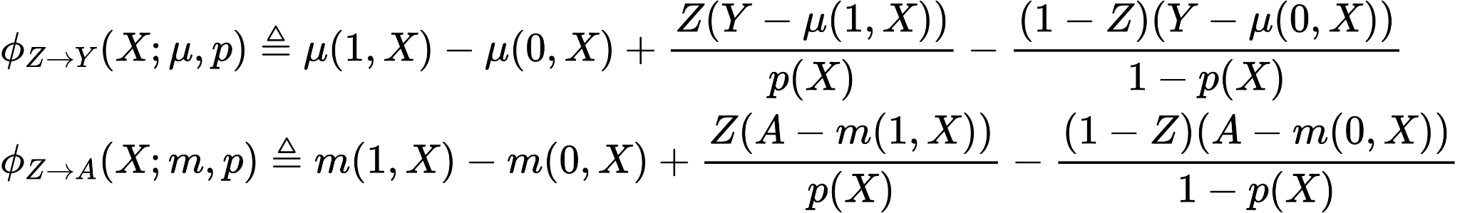

Using the components for $Y$ and $A$, in addition to the casual parameter $τ$ to be estimated, we have the score function:



1. Then we employ supervised machine learning, such as random forest or XGBoost, to fit models as estimates for $μ, m, p$.
2. Define as the solution to:

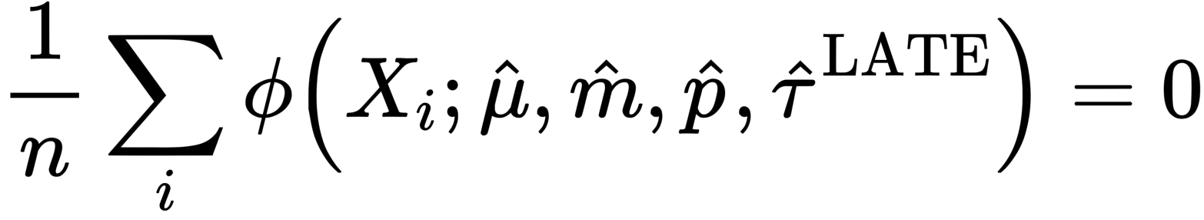

where we index the observation with $i$.

That is

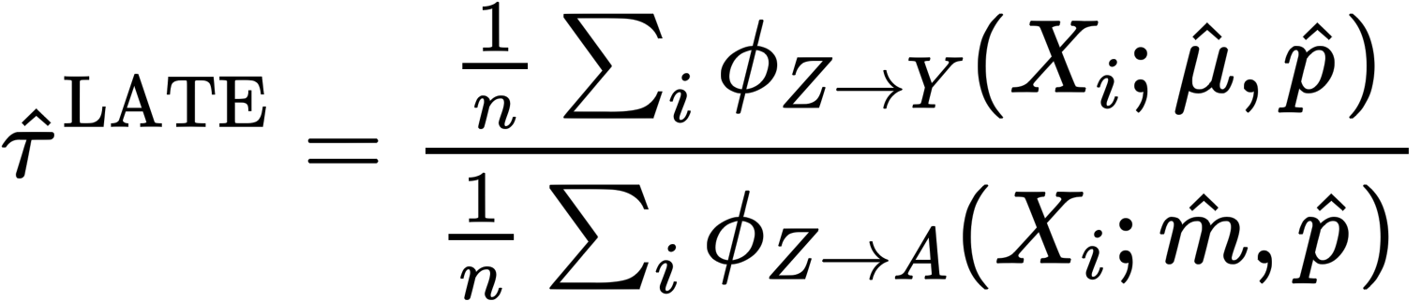.

Intuitively, it is effectively the double machine learning estimator of the average treatment effect of $Z$ on $Y$ divided by the double machine learning estimator of the average treatment effect of $Z$ on $A$.

We expect the same outcomes to part I, and we will compare the results to identify any discrepancies.

# 

# Bibliography

[Banerjee, B., & Zeman, J. (2022). Determinants of global value chain participation: Cross-country analysis. *Indian Economic Review*, *57*(1), 59–95. https://doi.org/10.1007/s41775-022-00137-w](https://www.zotero.org/google-docs/?SFMTG7)

[Borin, A., & Mancini, M. (2019). *Measuring What Matters in Global Value Chains and Value-Added Trade*. https://doi.org/10.1596/1813-9450-8804](https://www.zotero.org/google-docs/?SFMTG7)

[Cappelli, F., Carnazza, G., & Vellucci, P. (2023). Crude oil, international trade and political stability: Do network relations matter? *Energy Policy*, *176*, 113479. https://doi.org/10.1016/j.enpol.2023.113479](https://www.zotero.org/google-docs/?SFMTG7)

[Çetinkaya, C., & Özceylan, E. (2021). *A Logistics Performance Index Review: A Glance at the World’s Best and Worst Ten Performances* (pp. 24–42). https://doi.org/10.1007/978-3-030-89743-7_2](https://www.zotero.org/google-docs/?SFMTG7)

[Cotet, A. M., & Tsui, K. K. (2013). Oil and Conflict: What Does the Cross Country Evidence Really Show? *American Economic Journal: Macroeconomics*, *5*(1), 49–80.](https://www.zotero.org/google-docs/?SFMTG7)

[Karl, T. L. (1997). The Paradox of Plenty: Oil Booms and Petro-States. In *The Paradox of Plenty*. University of California Press. https://doi.org/10.1525/9780520918696](https://www.zotero.org/google-docs/?SFMTG7)

[Manole, V. (2005). Wits – World Integrated Trade Solution. *World Scientific Book Chapters*, 541–548.](https://www.zotero.org/google-docs/?SFMTG7)

[Rotnitzky, A., Robins, J. M., & Scharfstein, D. O. (1998). Semiparametric Regression for Repeated Outcomes with Nonignorable Nonresponse. *Journal of the American Statistical Association*, *93*(444), 1321–1339. https://doi.org/10.2307/2670049](https://www.zotero.org/google-docs/?SFMTG7)

[Sachs, J. D., & Warner, A. M. (2001). The curse of natural resources. *European Economic Review*, *45*(4), 827–838. https://doi.org/10.1016/S0014-2921(01)00125-8](https://www.zotero.org/google-docs/?SFMTG7)

# Appendix: List of Sectors from WIOD Long Run Data

We’ve hand selected sector 1, 2, 6, and 10 to examine the resource curse effect for now. It also is feasible to analyze other sectors, and we are looking forwards to suggestions on what sectors should we choose.

| Sector Name | Sector Group |
| --- | --- |
| 1-Agriculture, Hunting, Forestry and Fishing | Agriculture, forestry and fishing |
| 2-Mining and Quarrying | Mining and Quarrying |
| 3-Food, Beverages and Tobacco | Manufacturing |
| 4-Textiles, Textile, Leather and Footwear | Manufacturing |
| 5-Pulp, Paper, Paper, Printing and Publishing | Manufacturing |
| 6-Coke, Refined Petroleum and Nuclear Fuel | Manufacturing |
| 7-Chemicals and Chemical Products | Manufacturing |
| 8-Rubber and Plastics | Manufacturing |
| 9-Other Non-Metallic Mineral | Manufacturing |
| 10-Basic Metals and Fabricated Metal | Manufacturing |
| 11-Machinery, nec. | Manufacturing |
| 12-Electrical and Optical Equipment | Manufacturing |
| 13-Transport Equipment | Manufacturing |
| 14-Manufacturing, nec.; Recycling | Manufacturing |
| 15-Electricity, Gas and Water Supply | Electricity, Gas and Water |
| 16-Construction | Construction |
| 17-Wholesale and Retail Trade | Services |
| 18-Hotels and Restaurants | Services |
| 19-Transport and Storage | Services |
| 20-Post and Telecommunications | Services |
| 21-Financial Intermediation | Services |
| 22-Real Estate, Renting and Business Activities | Services |
| 23-Community Social and Personal Services | Services |

1. These countries are not meant to be an equal representation of all countries in the world. Rather, they are mostly oil-producing countries to enable our analysis of the oil-sector trade involvement effects. Yet, it would wrong to assume that every country in the globe has resources and capacity for substantial oil production.